FH,
A REPORT OF JOINT INVESTIGATION VISIT TO OANDO ENERGY RESOURCES LIMITED FACILITY AT 6” NEMBE-SOUTH/OBAMA FLOWLINE AT SABATORU, NEMBE LGA, BAYELSA STATE ON 2IST DECEMBER, 2024.
Please find below the highlights of the JIV to the above location.
- Company Address: Oando Energy Resources Limited, Mile 4, Ikwere Road, P.O. Box 923. Port Harcourt, Rivers State, Nigeria.
Location/Site Address: 6” Nembe-South/Obama Flowline at Sabatoru, Nembe LGA, Bayelsa State.
- Incident Number: 2024/SAR/259
- Pollutant Type: Crude oil
- Quantity spilled: 15bbls
- Area of impact: 38259.669M²
- Quantity Recovered: Nil
- Coordinates: N04⁰ 36’ 14.0” E006⁰ 20’ 5.7”
- Date of Incident: December 21st, 2024
- Date first reported: December 21st, 2024
- Inspection Date and Time: December 21st, 2024, 15:36hrs
- Inspection Team:
- EZEAMAECHI, EJIOFOR NOSDRA
- ALAGOA ETHEL EBILAYEFA BYSMENV
- Site Contact:
- ARISIMO ORIFIELATE OANDO HSE
- OKOKO STANLEY OANDO CRV
- ISAAC SIMON SURVEYOR
- Purpose of Inspection/Investigation: Event response.
- Compliance History: OANDO complied by reporting incidents within 24hrs as mandated in the Agency’s Regulation.
- Opening Conference: Toolbox meeting was held at the muster point (on top
of the barge) and the risks associated with the work and safety measures were highlighted including vital information about the spill incident.
- Walk through Inspection:
During the walk-through inspection of the incident site, the following were observed:
- The Joint Investigation Team (JIT) on arrival observed visible impact of oil on the surface.
- The suspected incident point was exposed with the aid of swamp buggy on the company’s ROW.
- The JIV team observed corrosion at 6 o’ clock position and repair was conducted afterwards.
- Based on the above observations, the JIT concluded that the incident was equipment failure.
- The other impacted communities (Sonomasegi, Kiminimi, Igbakiri, Obiama, Lalakubu, Erie, Solomonkiri, Onagatubu, Olosiegba, Amapegu, Kalatoru-Ama, Ebiema-Ama, Eyanbogu-Ama, Olakiri-Ama and Ogbointa-Ama) were delineated and captured.
- JIV was successfully concluded.
- Closing Conference: Signing of relevant JIV forms among all stakeholders
(NOSDRA, BYSMENV; COMPANY REPS. and COMMUNITY REPS.) were done in the field.
- Compliance Concerns: No compliance concern.
19. Record of Inspection:
NOSDRA form (JIV form)
Company form (OANDO form)
Personnel Report
20. Photography: The pictures below are visual evidence captured during the JIV.

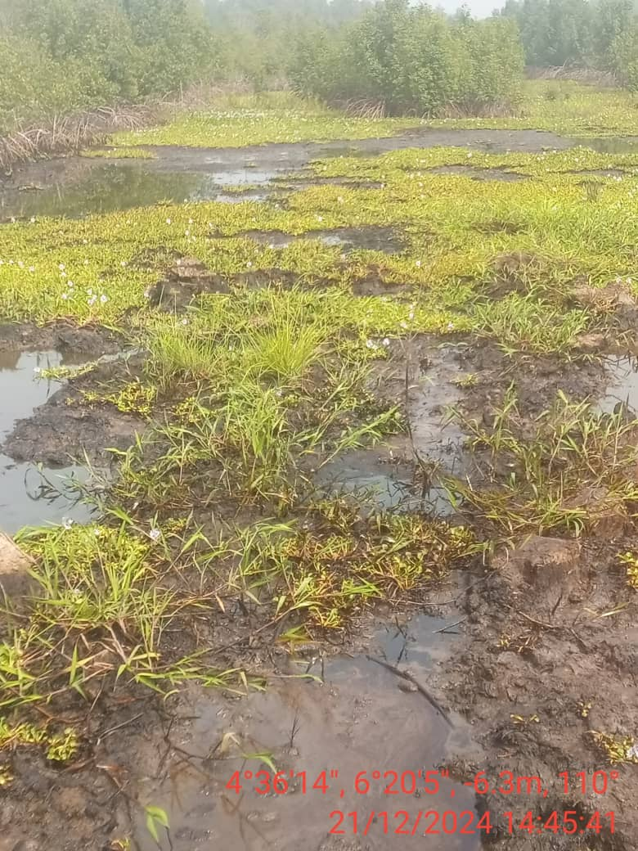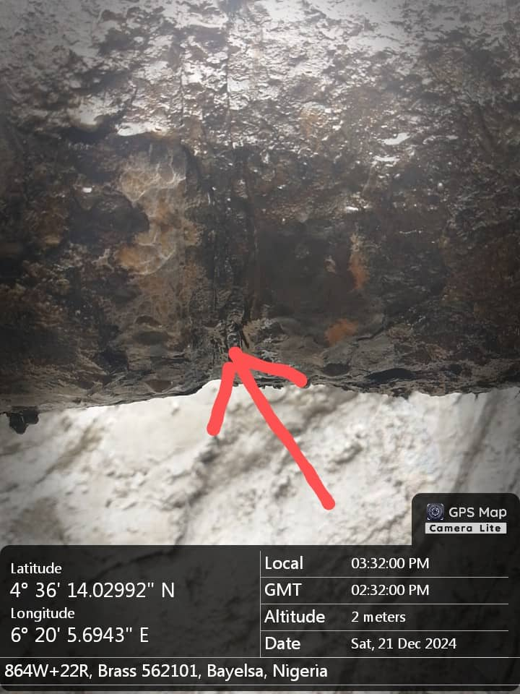
Fig. 1: The state of the environment at the time of JIV. Fig. 2: Corrosion at 6 o’ clock position

21. Recommendations:
- OANDO should clean up the impacted communities immediately.

This is submitted for your consideration and further directive, please

- 22. Signature and date:

Ezeamaechi, Ejiofor Chibuzor (SES).

